**Stage 5 – Vision leads the way**

**RULES:** USPSA Competition Rules, Latest Edition **COURSE DESIGNER:** Tom Castro

|  |  |
| --- | --- |
| **START POSITION: See written stage briefing.** | |
| **STAGE PROCEDURE**  See written stage briefing. | **SCORING**  **SCORING:** Comstock 26 rounds.  **TARGETS:** 9 cardboard targets and 8 steel targets  **SCORED HITS:** 2 Best hits per carboard will be scored. Steel must fall to score.  **START-STOP:**  Audible - Last shot  **PENALTIES:** Per USPSA Competition Rules |

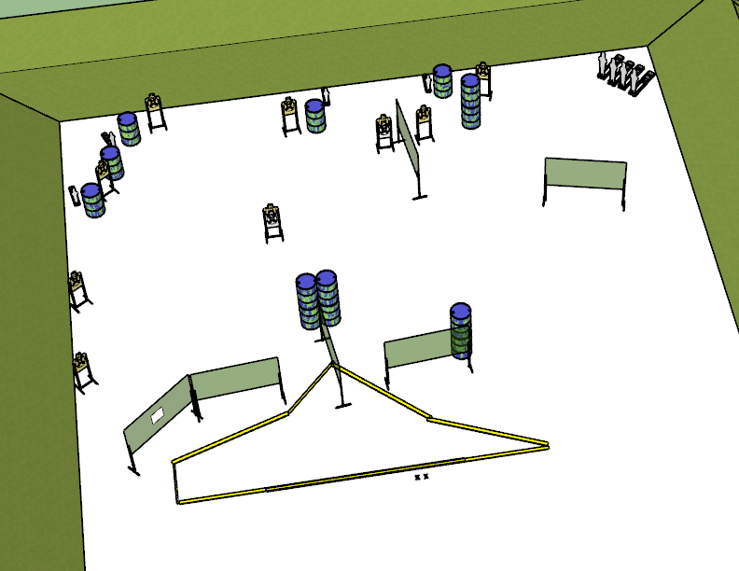

**Written Stage Briefing:**

**Stage 5 – Vision leads the way –** is a 26-round, 130 point, Comstock Long Course. There are 9 cardboard targets and 8 steel targets. The best 2 hits per cardboard target will be scored. The steel must fall to score.

**Start position** Both feet on the Shooting Sports Innovation Xs, facing downrange.

Handgun: Loaded and holstered with wrists below belt.

PCC: Loaded, stock on belt.

On the audible start signal, engage targets from within the shooting area.

**Setup Notes:**

10 Single Wall Stands

1 Double Wall Stand

5 Full Walls

1 Port wall

9 Target stands / 18 target sticks

4 mini poppers and bases

4 large poppers and bases

13+ barrels